Flow Name: Dynamic Dropdown – Smartsheet Picklist Synchronization

Problem:
Smartsheet dropdown (picklist) columns require manual updates to stay in sync with active client records. Without automation, dropdown values can become outdated, inconsistent across sheets, and prone to human error when clients are added, removed, or marked inactive.

Solution:
This automation dynamically generates dropdown options by extracting active client names from the Client Board and programmatically updating picklist columns in target Smartsheet sheets using the Smartsheet API.
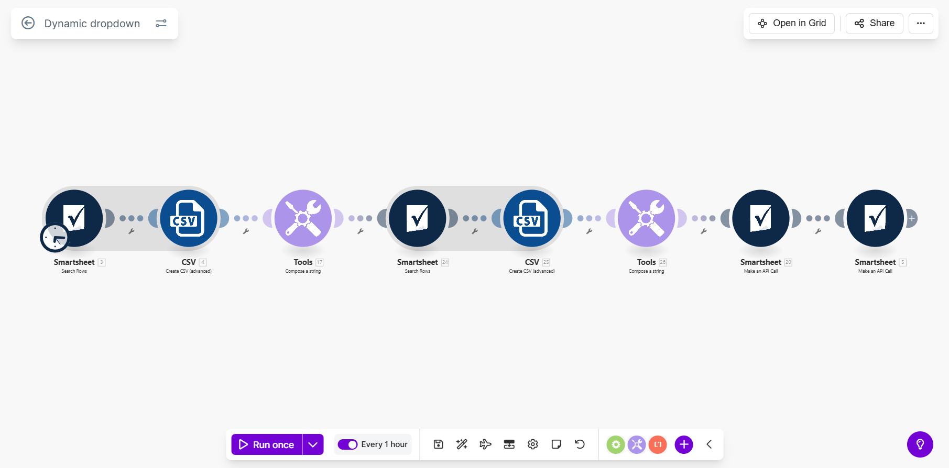
Flow Details:
Step 1: Load Active Clients from Client Board
The automation retrieves rows from the Client Board Smartsheet using the Search Rows module.
Only rows where the Active or Paused column is equal to Active are returned, ensuring that only currently active clients are considered.
Step 2: Aggregate Active Client Names
The retrieved active client rows are aggregated using a CSV advanced aggregator.
Only the Name on Invoices column values are included in the aggregation, producing a consolidated list of active client names.
Step 3: Normalize Aggregated Client List
The aggregated output is cleaned and normalized by removing carriage returns and replacing line breaks with comma-separated values.
This produces a single, API-ready list of client names.
Step 4: Load All Client Names from Client Board
A second Search Rows operation retrieves all rows from the Client Board where the Name on Invoices column exists.
This dataset is used to populate a separate dropdown that requires the full client list rather than only active clients.
Step 5: Aggregate Full Client Name List
All retrieved client names are aggregated into a single normalized text block using a CSV aggregator followed by a text transformer.
This produces a clean, comma-separated list of all client names.
Step 6: Update Picklist Column Using Smartsheet API (Active Clients)
A Smartsheet API PUT request updates a restricted single-select picklist column in the target sheet.
The dropdown options are replaced entirely with the dynamically generated list of active client names, ensuring full synchronization.
Step 7: Update Picklist Column Using Smartsheet API (All Clients)
A second Smartsheet API PUT request updates another picklist column in a different target sheet.
This dropdown is populated using the full client list, ensuring consistency across downstream workflows that require historical or inactive clients.

Overall Flow Summary:
This automation ensures Smartsheet dropdown columns remain accurate and dynamically synchronized with the Client Board. By programmatically extracting client data and updating picklist definitions via the Smartsheet API, the flow eliminates manual maintenance, prevents stale dropdown values, and guarantees consistency across dependent sheets and workflows.

